How to make a magnetic compass

What You Will Need
- Sewing needle about one to two inches long
- Small bar magnet or refrigerator magnet
- A small piece of cork (corks from wine bottles work well, but not the plastic stoppers) (Cut a larger cork into 4 pieces)
- A small glass or cup of water to float the cork and needle
- A small piece of sticky tac per group
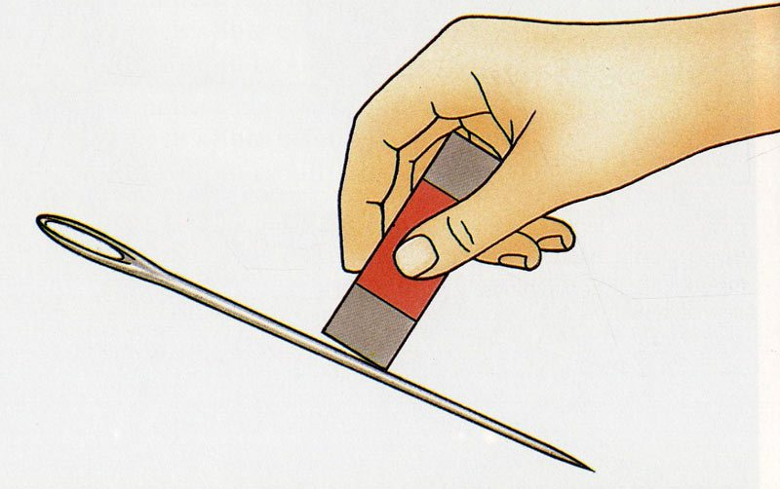
Method
    - Rub a magnet over the needle a few times, always in the same direction. This action magnetizes the needle.

    - Cut off a small circle from one end of the cork, about 1/4-inch thick. Lay the circle on a flat surface.

    - Use the sticky tac to attach the needle to the top of the cork.
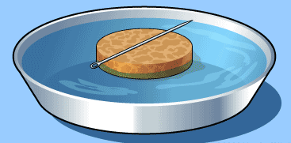
    - Fill the glass or cup about half full of water, and put the cork and needle assembly on the surface of the water.

    - Place your “compass” on a flat surface and watch what happens. The needle should point towards the nearest magnetic pole —north or south, depending upon where you live.

    - Try placing a magnet near your compass and watch what happens. How close does the magnet have to be to cause any effects? Try this again with a nail or other steel object. You can see why it’s important to keep metal objects away from compasses on ships!

