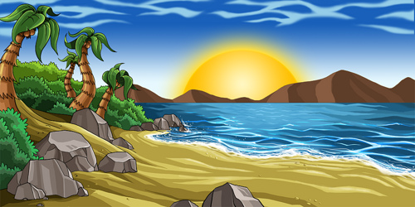
You are a writer and have been asked to write a short adventure story with the title: “The Mystery Island.”

In your travels on the ocean you come across an island unchartered on any map. Perhaps you were shipwrecked there or perhaps you stumbled upon it.
Write a short story describing the island. Consider the inhabitants – does anyone live there? What is the climate like? What is the landscape like?
Things you need to think about whilst writing:
- 1st or 3rd person? - Direct Speech
- Setting - Effective characters
- Alliteration - Senses
- Similes - Colours
- Onomatopoeia - Symbolism

